Course code: ECA3101
Course: Nano electronics
Exp 2: Simulation of Density of States of Quantum well structure with various nano meter thickness.
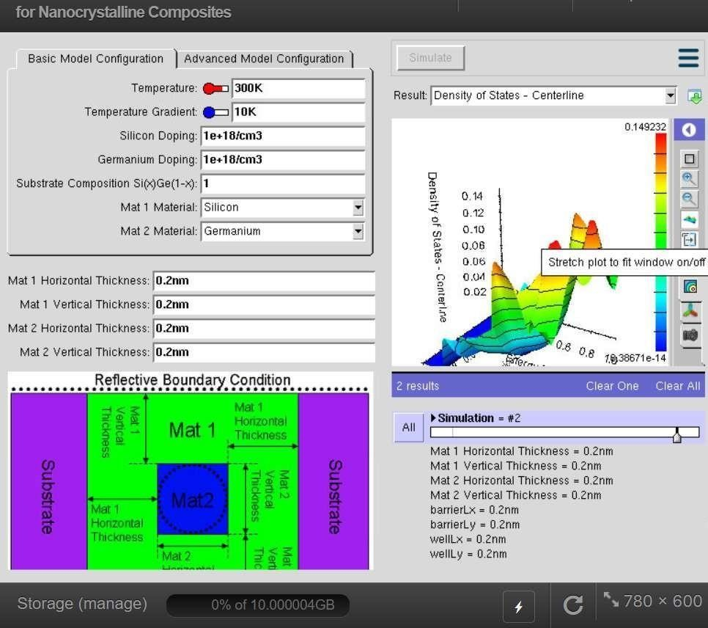
Why ?
It
•

Electrical

conductivity

•

Optical

absorption

•

Light

emission

•

Carrier

concentration

•

Device

performance

Without

knowing

DOS,

engineers

cannot

accurately

design

semiconductor

devices.

Output:

The purpose of this project is to understand how quantum confinement changes the Density of States (DOS) when the thickness of a quantum well is varied from a few nanometers to several nanometers. The Density of States tells us How many electron ^{determines}energy states are available at each energy level. • How electrons occupy energy levels
Case study 1: Simulate the density of states of quantum well of thickness 0.5 nm
Aim: To simulate the Density of States (DOS) of a quantum well structure with a 0.5 nm well thickness
and analyze the effect of strong quantum confinement on the available electron energy states.

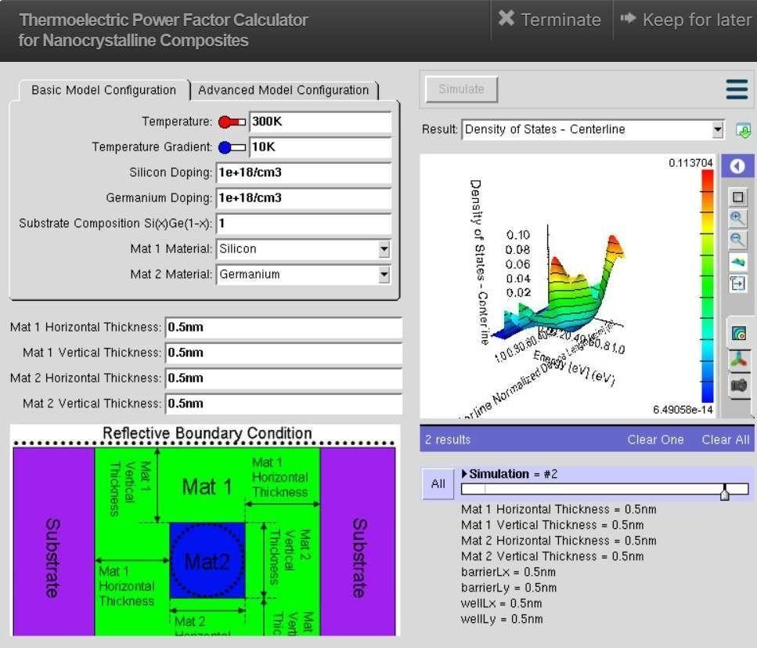
Case Study 2: Simulate the density of states of quantum well of thickness 0.6 nm
Aim: To simulate the Density of States (DOS) of a quantum well structure with a 0.6 nm well thickness
and investigate the effect of increased well thickness on the electronic energy states.

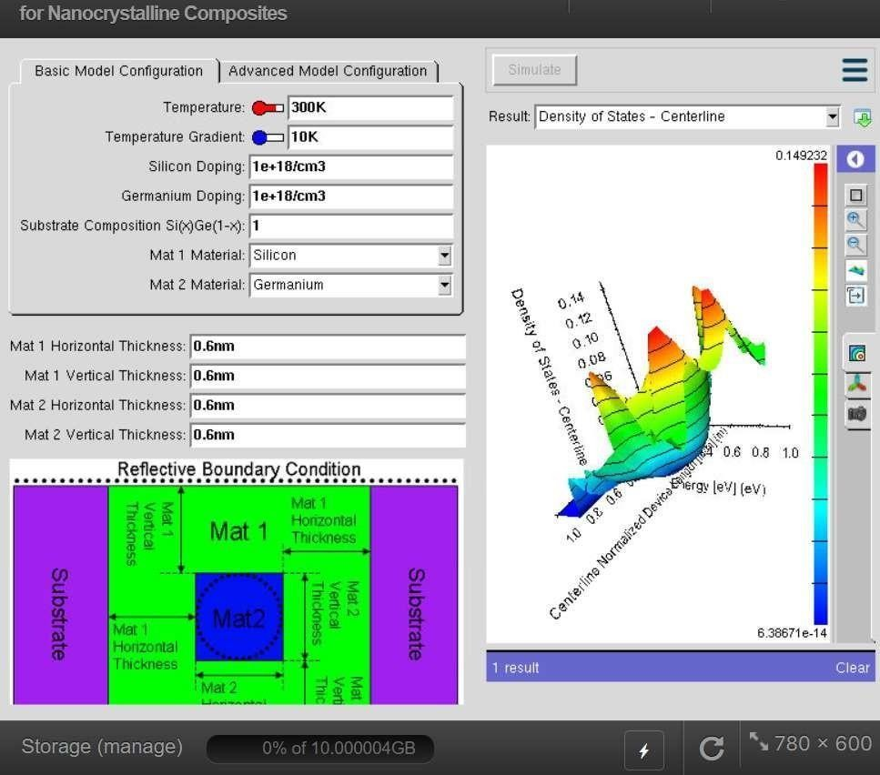
The simulation of the Density of States (DOS) for quantum well structures with different nanometer thicknesses demonstrates that quantum confinement strongly influences the electronic properties of semiconductor nanostructures. As the well thickness decreases, the energy levels become more discrete and widely spaced, resulting in significant changes in the Density of States. Conversely, increasing the well thickness reduces the confinement effect, causing the DOS to gradually approach that of a bulk semiconductor. These results confirm that quantum well thickness is a critical design parameter for tailoring the electronic and optical characteristics of devices such as quantum well lasers, LEDs, photodetectors, and other nanoelectronic applications.

